The 5 Rules of Straight Razor Safety
By Joe Borrelli
Interested in trying a straight razor? A little nervous? Don’t be. Using a straight razor can be a very rewarding experience. It’s something you can look forward to doing every day and a skill that will last a lifetime. Although there are countless articles that contain guides on what items to buy, where to buy them and how to actually shave, there’s one subject that seems to be left out — safety. In fact, it’s so overlooked that a simple search on the internet comes up almost empty handed.
After a friend of mine was injured about a year ago, I created a thread on a popular wet shaving forum regarding several rules that should be followed when handling a straight razor. This thread is now a permanent “sticky” on the site and can be viewed here. I have modified the guide to make it easier to understand for lurkers and experts alike. We’ll call it for arguments sake: “The Five Rules of Straight Razor Safety”.
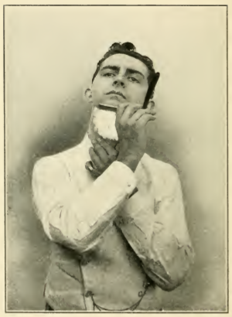
While extremely important, safety is one of the most overlooked subjects in the straight razor industry.

Rule #1: Running Late… It Can Wait!!
We’ve all been there. The alarm didn’t go off, the dog ran out, you spilled coffee on your shirt. Running late happens, and when it does we typically cut corners in our routine to make up for lost time.
Straight shaving requires the user’s full attention. Cutting corners can lead to injury. If you’re short on time, your best bet is to put the razor down and switch to a safer form. Keep a stash of disposables close by or grab that neglected double-edge razor that’s hidden in a drawer since you switched the “dark side” of shaving.
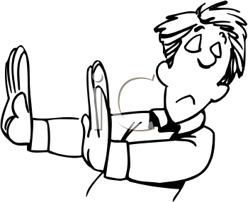
Just say “no” if you can’t give straight razor shaving your full attention.
Rule #2: Eliminate Distractions
The phone rings, the wife looking for her makeup or the kids barging in to brush their teeth. This can be really distracting when you’re trying to concentrate. Keep the distractions to a minimum. Make shaving “your time.” The last thing you want is someone hitting you with the door while you’re shaving your upper lip (I’ve been there).
I’m not much for locking the door when shaving because if something were to happen it would delay my rescue. I made up a sign to hang on the door to let everyone know to knock before entering. Feel free to download the sign for your own use here.

Minimize distractions before you shave.
Rule #3: Protect Yourself
Always wear a towel or robe to protect the most important parts of your body. Invest in a mat to prevent slipping and use another towel to put over your feet just in case the razor falls. Always remember… NEVER TRY TO CATCH A FALLING RAZOR!!!
I would avoid straight shaving in the shower while we’re on the subject. Some guys do, and swear by it. I for one feel that the cons outnumber the pros in that particular situation.

Rule # 4: Never Try to Catch a Falling Razor!!
This is so important I’m mentioning it twice. Enough said. You’re holding possibly the sharpest knife you’ve ever held. Your fingers don’t grow back. Trying to catch razors may be the number one cause for injury in straight shaving. A chipped blade is much easier to repair than fingers and toes.
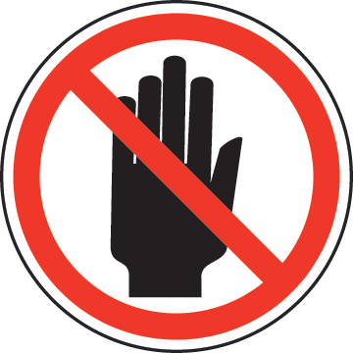
Catching razors may be the top cause for injury in straight shaving… don’t do it!

Rule #5: Follow Basic Knife Safety:
As they teach you with standard knife safety, make sure your razor is sharp. A dull razor will cause you to press harder against your skin and go over spots multiple times. Maintain your razor and hone or send it out when it is no longer sharp.
Don’t forget to take proper care when opening and closing the blade. Make sure you close the blade in between passes, when lathering or when you’re not using it. If you own a Japanese Kamisori-style razor, I find that a piece of painters tape with about a ¼ inch clearance from the edge works very well. No tape residue and it won’t affect the blade.
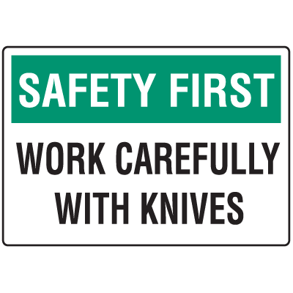
So there you have it! The five rules of Straight Shaving Safety. Hope this helps clarify some questions and help prevent future mistakes that may harm you. Thanks for taking the time to read this and…
… Happy Shaving!!!!!
Links for pictures:
http://theredish.com/img/dd1%2520cartoon
https://www.google.com/url?sa=i&rct=j&q=&esrc=s&source=images&cd=&cad=rja&uact=8&ved=0ahUKEwimqLmVyr3JAhVH4CYKHZHADbsQjRwIBw&url=http%3A%2F%2Fwww.seton.com%2Fknife-safety-signs-safety-first-91822.html&psig=AFQjCNE0wq6gJcZKYgMlas-IpOZCuoLxLQ&ust=1449159425810500
http://www.safetysign.com/images/catlog/product/large/J6512.png

